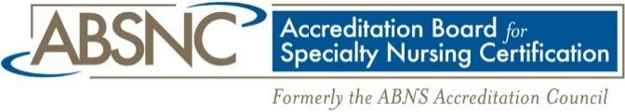

FOR IMMEDIATE RELEASE

Felicia Lembesis, CAE
Executive Director
856-642-4430
info@absnc.org

Dermatology Nurse Practitioner Certification Board
Receives Accreditation of its DCNP Examination and Credential
From the Accreditation Board for Specialty Nursing Certification

November 9, 2021 —The Accreditation Board for Specialty Nursing Certification (ABSNC), is pleased to announce Dermatology Nurse Practitioner Certification Board has been granted accreditation for the DCNP Examination and Credential certification programs.

The DNPCB believes that attainment of a common knowledge base, utilization of the nursing process, and a high level of skill in the practice setting are required for dermatology nurse practitioner practice and should receive professional recognition.

The DNPCB is committed to the advancement of professional nursing through recognition of nurse practitioners displaying knowledge and expertise in the specialty practice of dermatology. In doing so, the DNPCB recognizes the value of education programs, research, and clinical practice which fosters personal and professional growth.

“Obtaining the ABSNC accreditation is a momentous step for our profession. Our DCNP certificate holders, board and leaders are honored to have their work recognized by the ASBNC,” said Megan Ferguson, President DNPCB.

ABSNC accreditation is a peer-reviewed mechanism that allows nursing certifying organizations to obtain program accreditation by demonstrating compliance with the highest quality standards in the industry. To maintain accreditation, programs must exhibit continuing adherence to the 18 standards set forth. “ABSNC Accreditation represents a recognized standard in certification testing and indicates that the credential meets or exceed legal and regulatory guidelines,” said Felicia Lembesis, CAE, Executive Director.
The mission of ABSNC is to recognize quality specialty nursing and associated non-RN certification programs through accreditation. It is the only accrediting body specifically for nursing certification. ABSNC currently accredits more than 60 certification programs from 20 specialty nursing certification organizations. The accreditation standards offered by ABSNC include Examination-Based Certification Programs, Portfolio Assessment Certification Programs, and Assessment-Based Certificate Programs. For more information about ABSNC and its accreditation standards, please visit www.absnc.org or contact Felicia Lembesis, ABSNC Executive Director, (flembesis@ahint.com, 856-439-9080).
For more information about obtaining a DCNP, contact Tracy Schorle, DNPCB Senior Director, (tschorle@dnpcb.org)

